Visualization of a production line controlled by a PLC

(Car production)

Nagy Zsolt – F6ZKWV

Automatic manufacturing systems project I.

Purpose, introduction:

I have chosen this kind of topic because I am interested in PLCs and I am working in this field.

The name of my topic is Visualization of a production line by a PLC.

This kind of visualization presents the animation of a car production that is controlled by a Simatic S7-300 PLC or S7-1500.

Requirements:

The **first requirement** is that the pressing cylinder have to form a car from a raw material (cube) which is coming from a pre-processing unit.

The **second requirement** is that a spray booth has to paint the car.

The **third requirement** is that the painted car has to be located in a warehouse which will be chosed by according to the colour of the car.

Features:

First step is a material coming from the pre-processing unit to the place where a pressing cylinder is going to form a car from the material. Then when this has happened then the car moves to the spray booth where the car will be painted (3 colors:red, green, blue) randomly. After that the car goes to the warehouse but the storage depends on the color of the cars because it will be 3 different colored warehouse.

Functional description:

* **Input**: The starting button on the production line will be an enable input.
* **Output**: We can see the whole procces on the screen of the PC.

Figure of the setup, architecture:

* **Block diagram**:

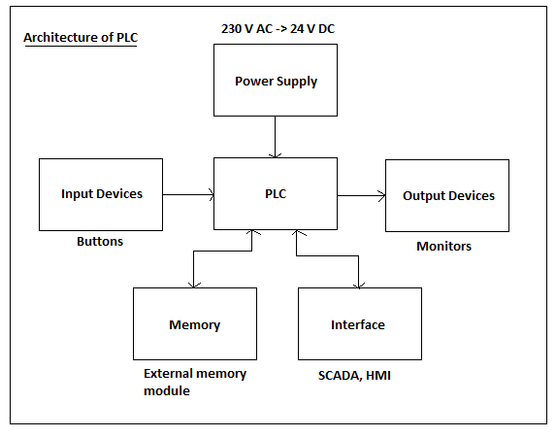

* **Communication**: Profinet

Implementation description:

* **Hardware (in the visualization)**: There will be sensors (10-12), warehouses (3), spray booth (1), conveyor belt,

material handling equipment (slider)(1-2), machinig tool (pressing cylinder) (1) pre-processing unit(1).

* **Software**: TIA Portal V13 SP1

Step7 Professional V13 SP1

WinCC Professional V13 SP1

WinCC SCADA Runtime V13 SP1

My project has two parts. First the visualization part and then the controlling part. The visualization part will be do in the WinCC and the controlling part in Step7.

Using SCADA HMI.

Verification against requirements:

Each small parts is tested step by step to avoid errors.

Error handling (including negative errors).

Validation test to prove that the process is good enough.

PLC programming is tested with PLC simulator and also with the PLC.

The visualization can be tested with the correct PLC program.

Gantt chart:

|  |  |  |  |  |  |  |  |  |  |  |  |  |  |  |
| --- | --- | --- | --- | --- | --- | --- | --- | --- | --- | --- | --- | --- | --- | --- |
|  | 8th of february | 15th of february | 22th of february | 29th of february | 7th of march | 14th of march | 21th of march | 28th of march | 4th of april | 11th of april | 18th of april | 25th of april | 9th of may | 2nd of may |
| Weeks: | 1 | 2 | 3 | 4 | 5 | 6 | 7 | 8 | 9 | 10 | 11 | 12 | 13 | 14 |
| Choosing the idea | - |  |  |  |  |  |  |  |  |  |  |  |  |  |
| Specification |  |  |  |  |  |  |  |  |  |  |  |  |  |  |
| Extended specification |  |  |  |  |  |  |  |  |  |  |  |  |  |  |
| Starting the visualization |  |  |  |  |  |  |  |  |  |  |  |  |  |  |
| Visualization |  |  |  |  |  |  |  |  |  |  |  |  |  |  |
| Visualization |  |  |  |  |  |  |  |  |  |  |  |  |  |  |
| Finishing visualization |  |  |  |  |  |  |  |  |  |  |  |  |  |  |
| Starting the controlling |  |  |  |  |  |  |  |  |  |  |  |  |  |  |
| Controling |  |  |  |  |  |  |  |  |  |  |  |  |  |  |
| First demo |  |  |  |  |  |  |  |  |  |  |  |  |  |  |
| Upgrading and checking |  |  |  |  |  |  |  |  |  |  |  |  |  |  |
| Final demo |  |  |  |  |  |  |  |  |  |  |  |  |  |  |

Milestones:

1.HW Config 4. Presentation

2.Visualization 5. Final demo

3.Controlling